Exercise 1

cd kafka_2.12-3.8.0\bin\windows

XML

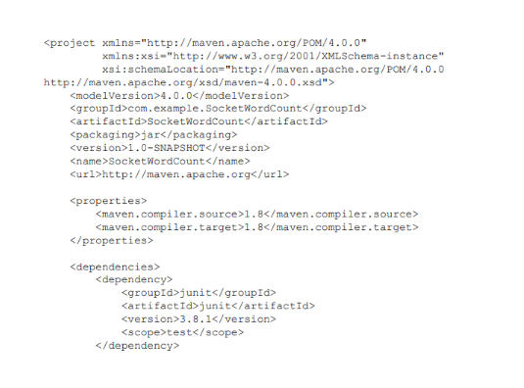

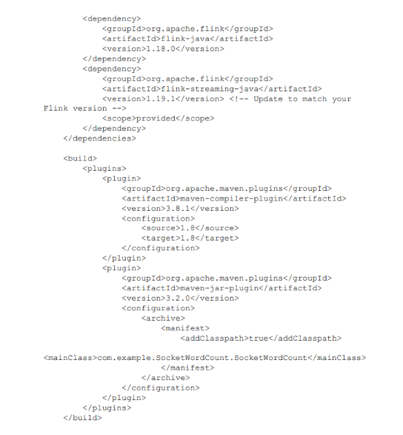

JAVA Code:

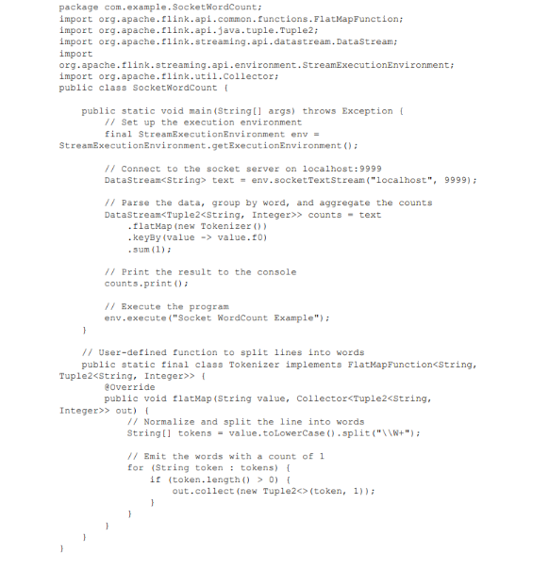

Exercise 2

Python Code  
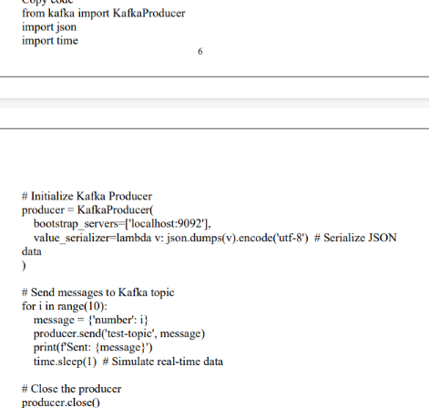

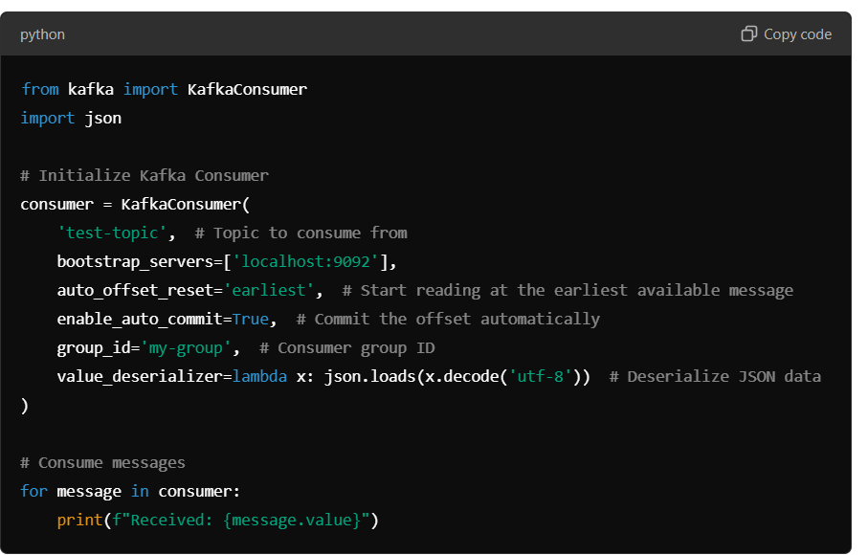

Exercise 3

XML Code:

Java Code:

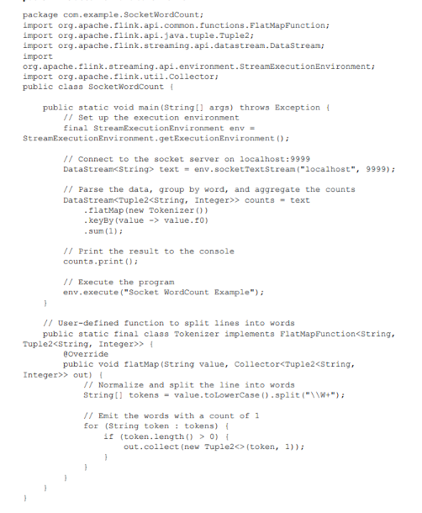

Exercise 4:

Exercise 5:

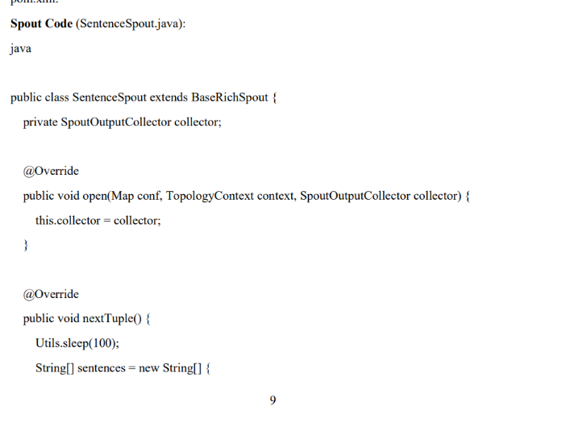

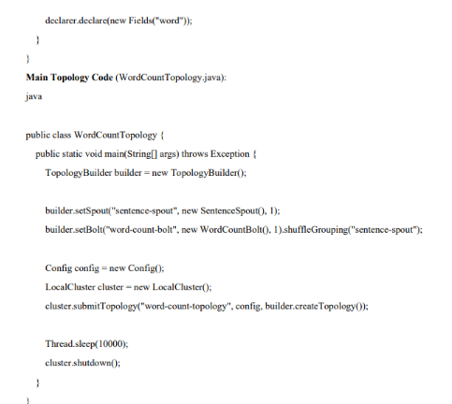

Exercise 6

Python Code:

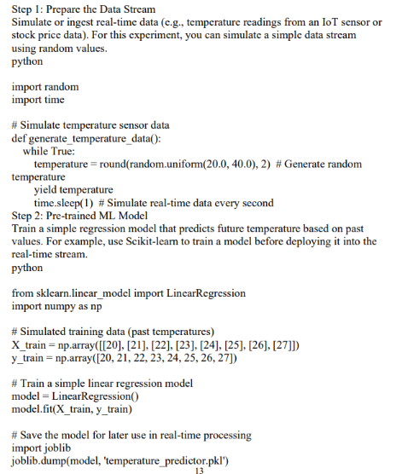

**Exercise 7**



